**Lab Exercise 6.1 Managing Jenkins Freestyle Jobs**

**Name - Arin Agrawal**

**SapID: 500120660**

**Roll no:R2142230502**



# Step 1: Create a new Freestyle Job

* 1. Open the browser, go to the Jenkins Dashboard by typing **localhost:8080** in your browser, provide the credentials, and click the **Sign in** button

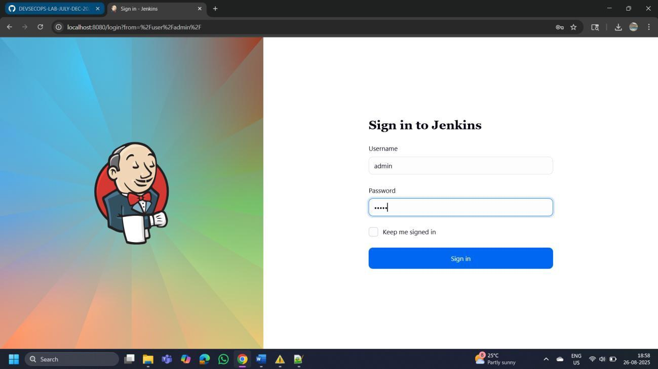

* 1. Click on **New Item** in the Jenkins **Dashboard**

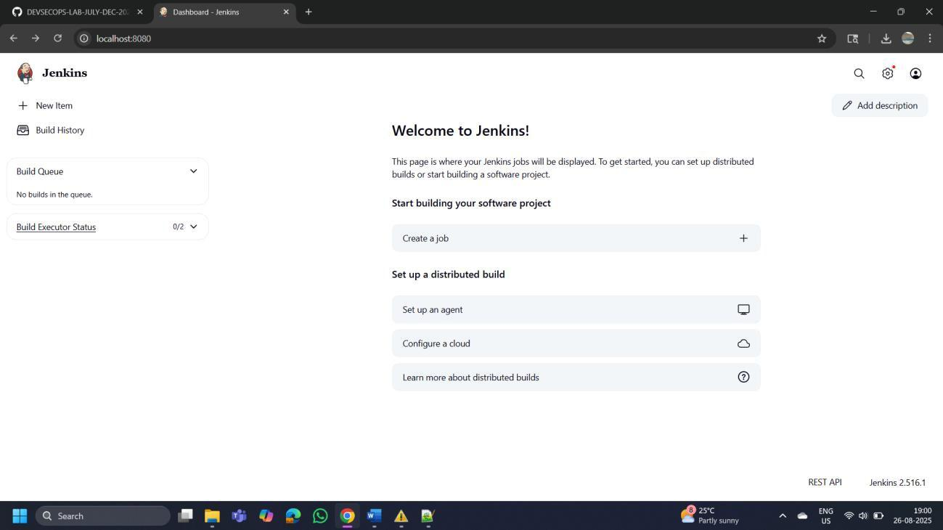



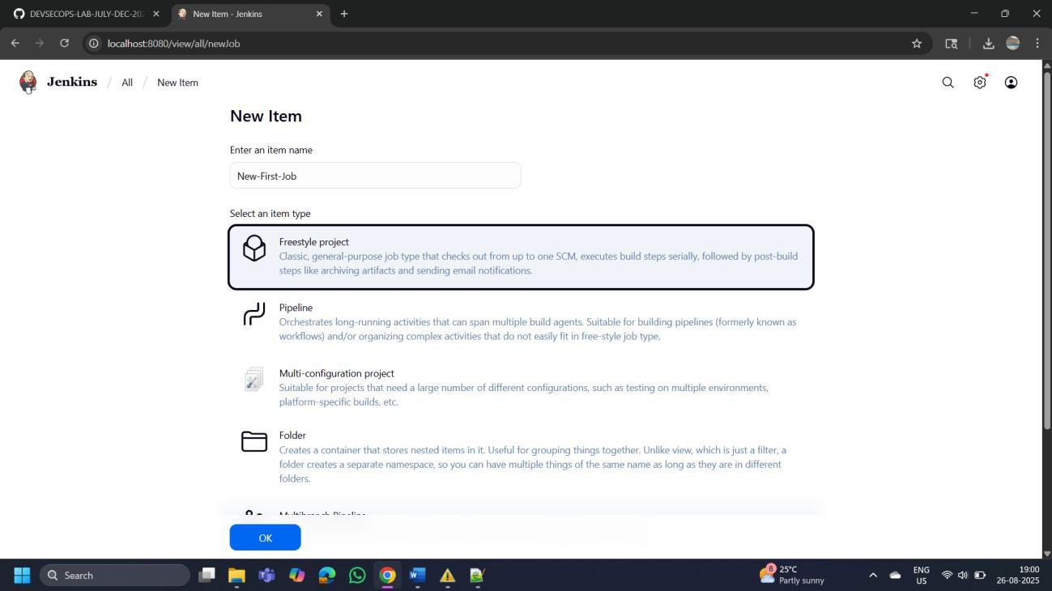



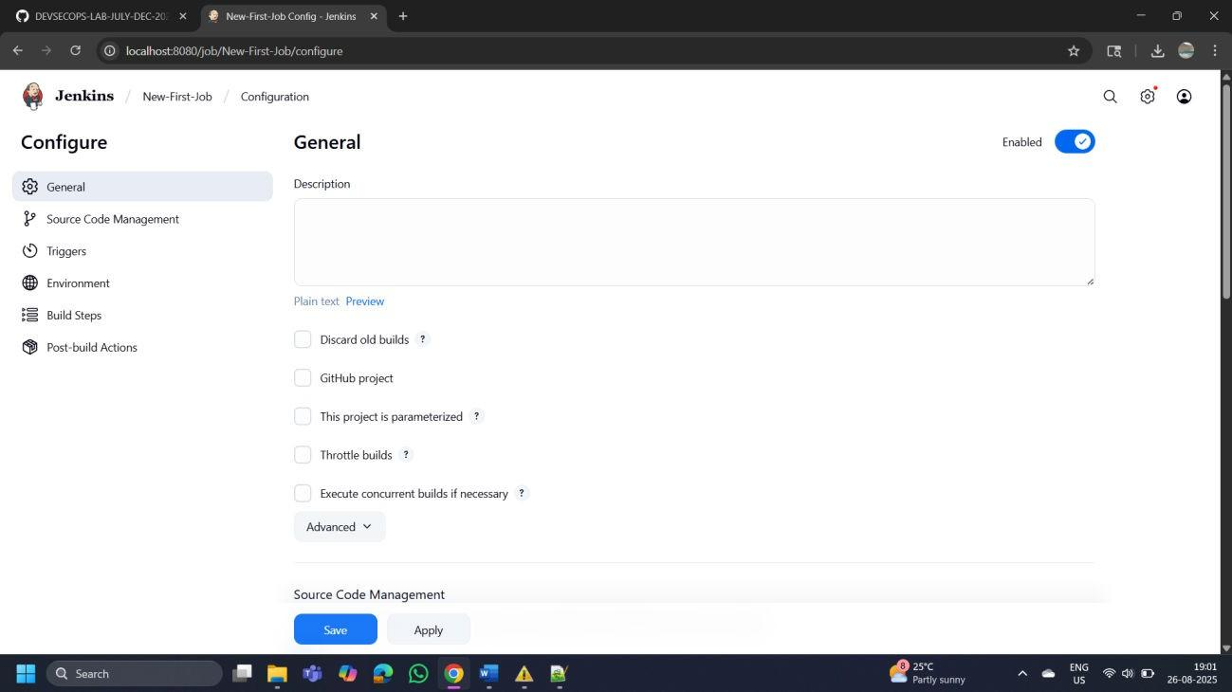

# Step 2: Rename and delete the Freestyle Job

* 1. Click on the name of the project that you have created as shown in the screenshot bELOW

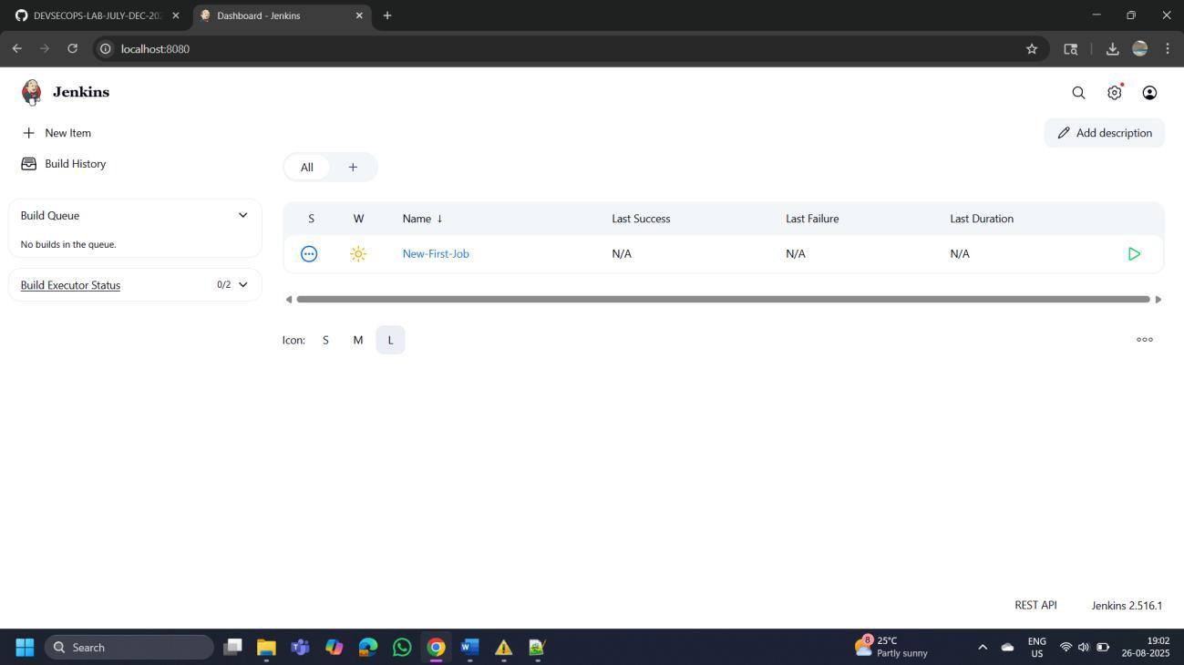

* 1. Click on the **Rename** button to rename the project

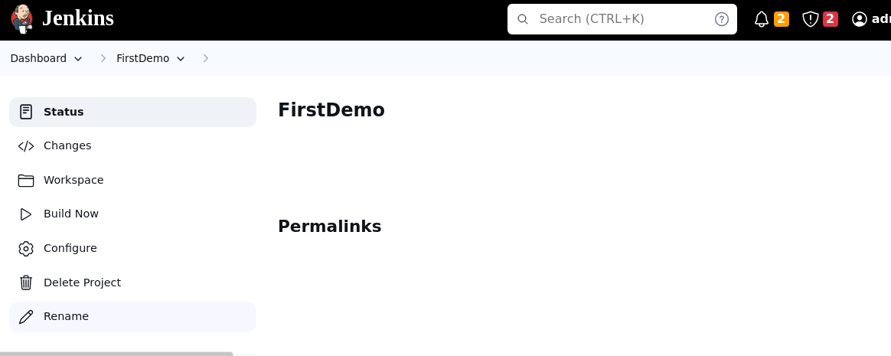

* 1. Enter a desired name to the project and click on **Rename**

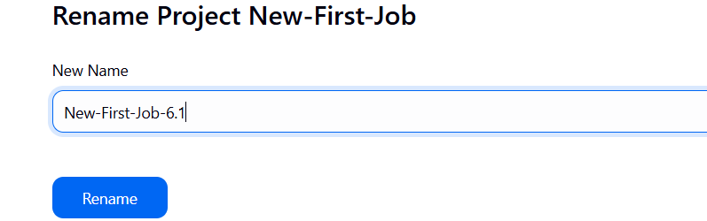

* 1. Click on the renamed project and then click on **Delete Project** to delete the project

